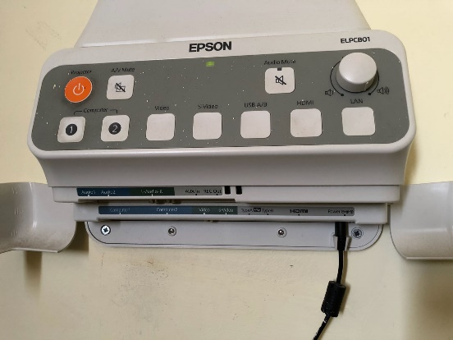

1

3
2

4

5

6

7

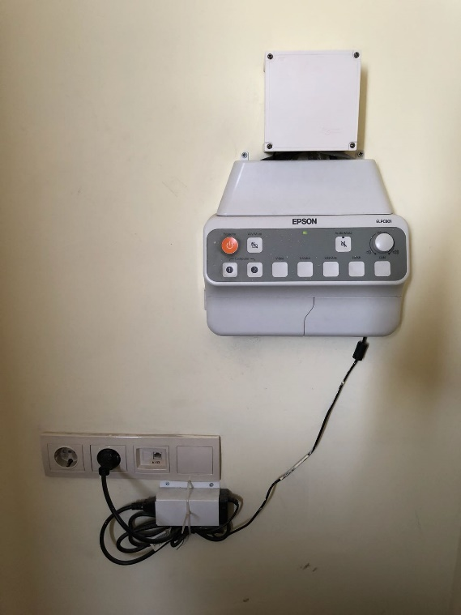
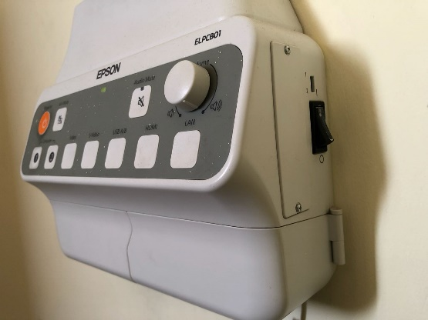

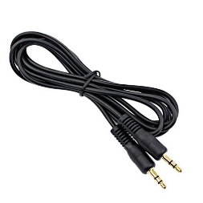
8

9

10

11

- Projections on-off button
- Projections VGA selection button
- Projection HDMI selection button
- Sound cable socket 8. Control panel power led
- VGA socket 9. Control panel power button
- HDMI socket 10. Control panel power cable
- Control panel power input cable 11. Sound cable

Make sure that the power cable (10) the control panel of the projection is plugged in the IPS socket, the power input cable (7) is plugged in the control panel, the power button (9) is open, and the power led (8) is lit. The projection is set on by pressing the button (1). Open the laptop computer. In order to reflect the screen image of the laptop to the curtain, place the appropriate image cable into the VGA (5) or HDMI socket (6) at the bottom of HDMI socket. The other end of the image cable is placed into the VGA or HDMI socket of the laptop. If VGA socket is used on the control panel, press button (2) and if HDMI socket is used press button (3). If the image is not automatically reflected on the curtain, press Windows+P keys () all together, and select the “Dublicate” option on the pop-up menu. For a HDMI connection, the sound level can be set via the round volume button on the computer sound control and control panel. For a VGA connection, it can be set in the same manner by placing one end of the sound cable (11) into the sound socket (4) and the other end into the computer sound socket.

