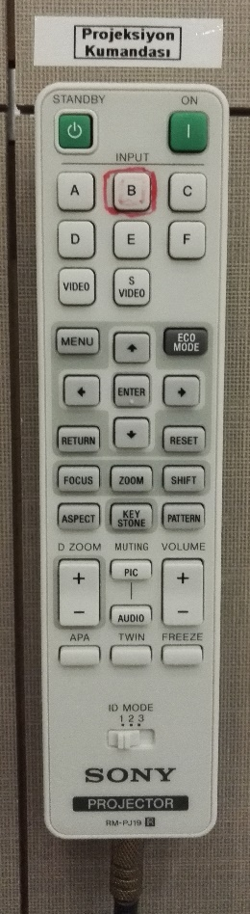
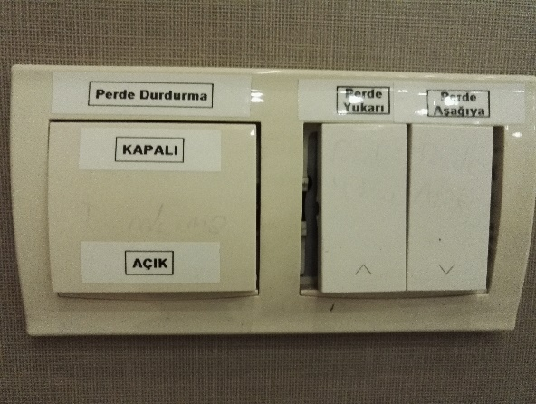
1

2
3

5

4

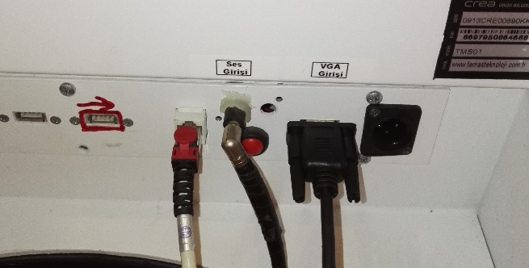

7

6

10

9

8

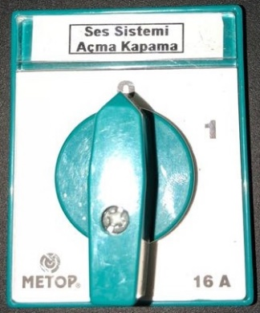
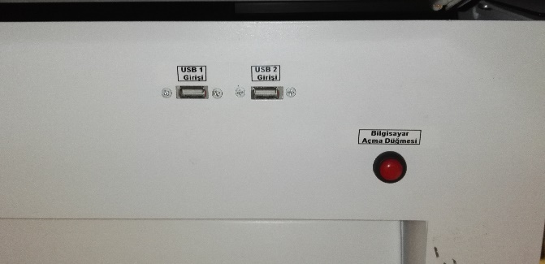

- Projection on button
- Projection off button
- Projection input selection button
- Curtain pause button
- Curtain scroll down/up button 8. USB 1 and USB 2 sockets
- Sound socket and sound cable 9. Computer on button
- VGA socket and VGA cable 10. Sound system opening switch

Projection equipment is set to on position by pressing the button (1). Press input B button (3). In order to energize the projection curtain, set the curtain pause button (4) to onn position. Open the curtain by pressing curtain scroll down button (5). In order to turn on the desk computer press the red button (9). To reflect the image of the smart desk computer’s image to the curtain, insert the image cable into VGA socket (7). If a laptop is to be used, then turn on the laptop. To reflect the image of the laptop screen’s image to the curtain, insert the image cable into the laptop’s VGA socket. If the image is not automatically reflected on the curtain, press Windows+P () keys all together, and select the “Dublicate” option on the pop-up menu. If the sound system is to be used, set the sound system on-off switch (10) to “1” position. Insert the sound cable (6) into the smart desk’s or laptop’s sound socket. If an external flash memory is to be connected to the smart memory, then the USB1 or USB2 socket (8) located at the bottom of the keyboard can be used.

