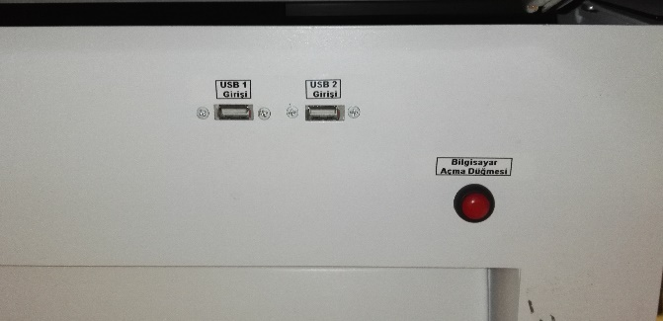
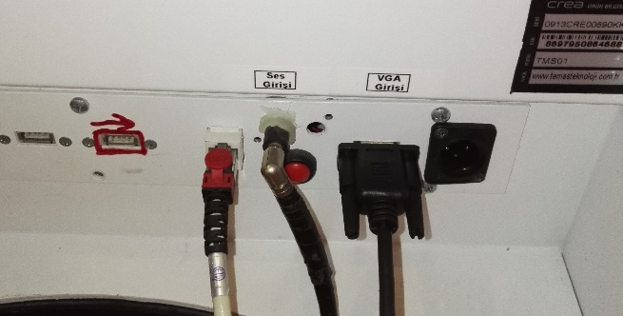
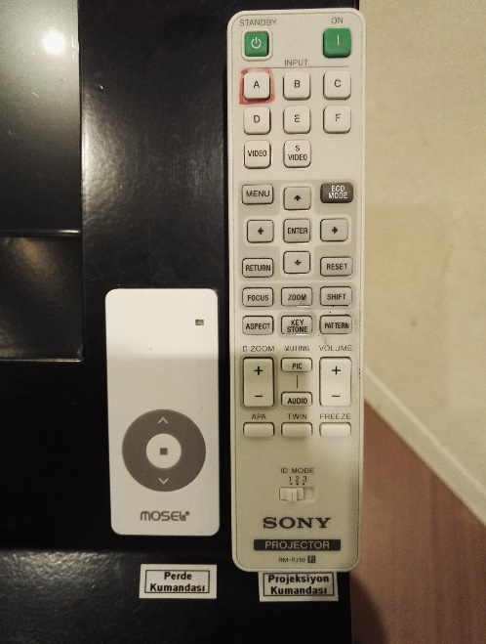
1
7
6

5

2

3

4

8

- Projection on button
- Projection off button
- Projection input selection button
- Curtain opening/closing control
- Sound socket and sound cable
- VGA socket and VGA cable
- USB 1 and USB 2 socket
- Computer on button

The projection equipment is set to on position by pressing the button (1). Press Input A button (3). Press button (V) of the control (4) to open up the projection curtain. Press red button (8) to turn on the desk computer. To reflect the image of the smart desk computer’s image to the curtain, insert the image cable into VGA socket (6). If a laptop is to be used, then turn on the laptop. To reflect the image of the laptop screen’s image to the curtain, insert the image cable into the laptop’s VGA socket. If the image is not automatically reflected on the curtain, press Windows+P () keys all together, and select the “Dublicate” option on the pop-up menu. If the sound system is to be used, insert the sound cable (5) into the smart desk’s or laptop’s sound socket. If an external flash memory is to be connected to the smart memory, then the USB1 or USB2 socket (7) located at the bottom of the keyboard can be used.

