AIRCONDITIONER CONTROL PANEL IN THE COMPUTER LABORATORIES NOS. 314,324,325,318,319 AT Y BLOCK 3RD FLOOR.
The air-conditioners installed in the classrooms nos. Y318, 319, 314, 324, 325 have no connection to the automation system. There is a main control for the air-conditioners in the classrooms Y318 and 319. And the ones installed in Y318 and Y319 operate in the desired mode independently
The air-conditioners in the Y314-324-325 classrooms have a central vrf system. These locations are air conditioned in one single mode. If different modes are set, the air-conditioning system will not operate. The control panels are open for use by people.

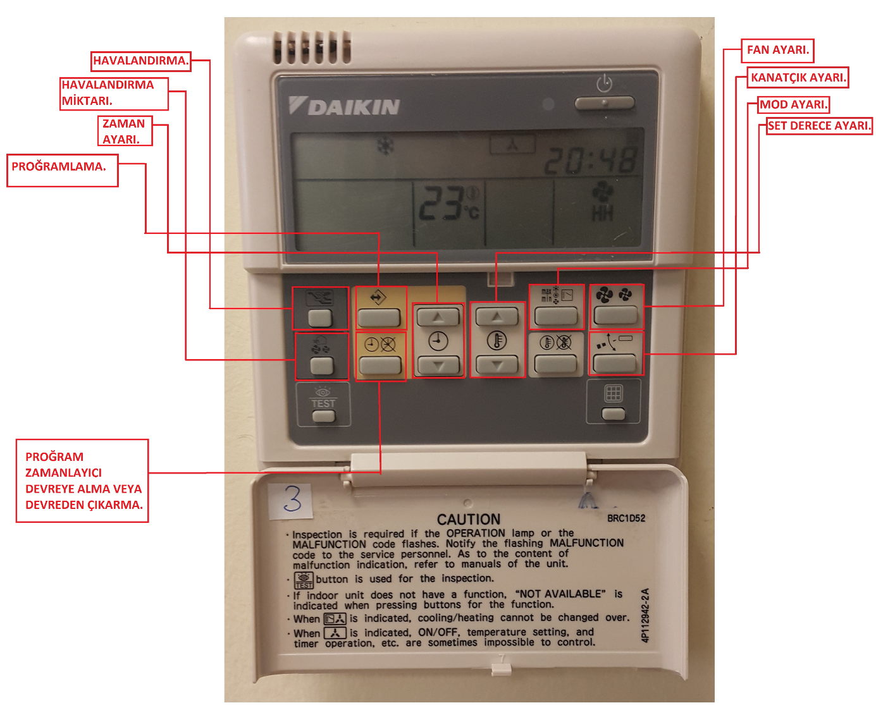

MITSUBISHI AIRCONDITIONER CONTROL PANEL FOR THE INCUBATION CENTERS AT T BLOCK and Y BLOCK.
These control panels have their central controls. The air-conditioners are operated via such controls according to the setting done by our technical service.
The users at the locations cannot change the mode setting or temperature settings of the air-conditioners. However, the on-off button, fan speed setting button and flap setting are open for use by the people at the locations.

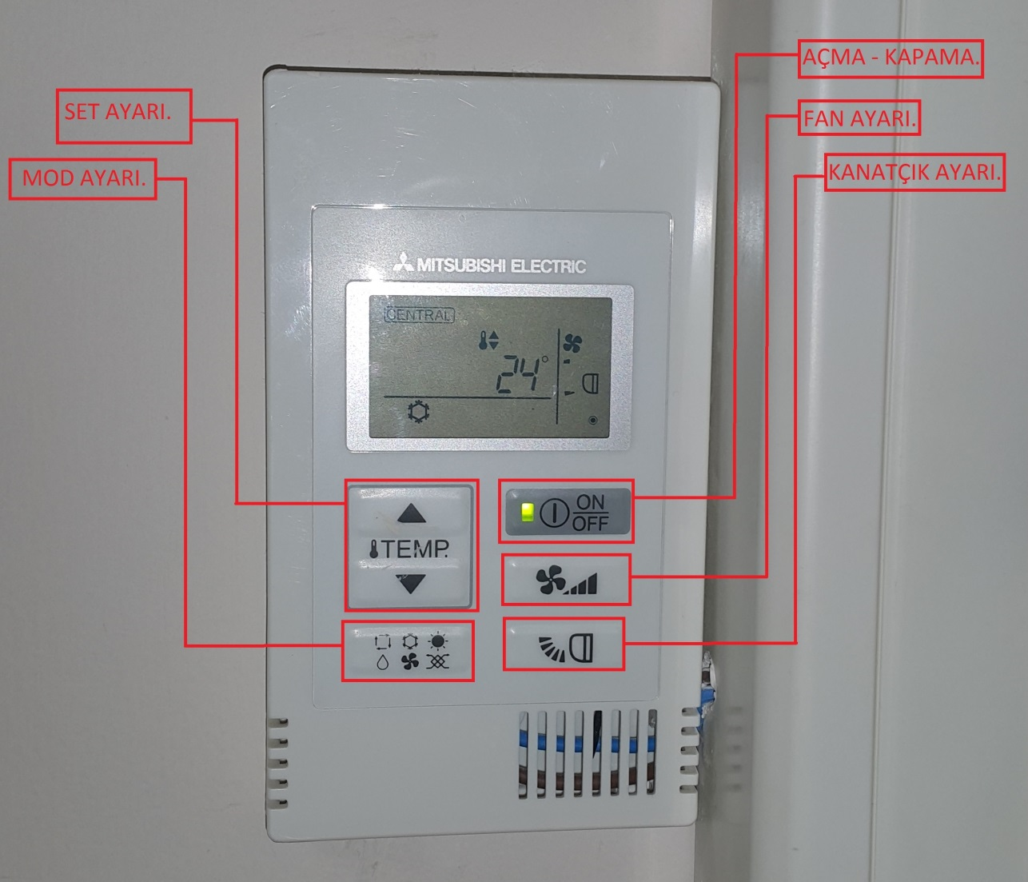

Y BLOCK FANCOIL CONTROL PANEL
The control panel of the fan coil devices in the Y block central air-conditioning system is connected to the automation. The on-off button, fan speed setting button and flap setting are open for use by the people at the locations.

