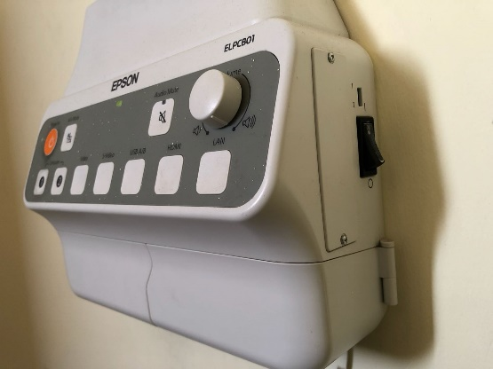
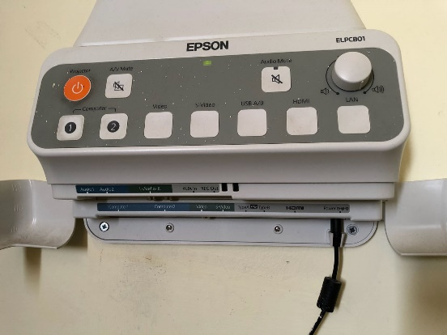

5

6

4

3
2
1

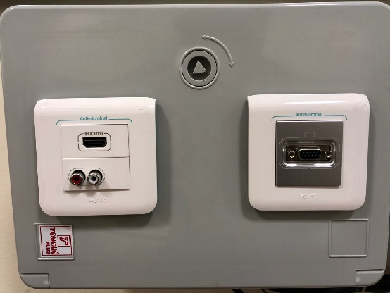
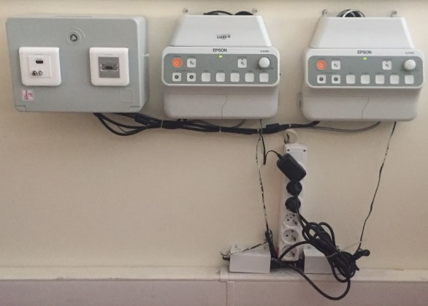

8

7

10

9

11

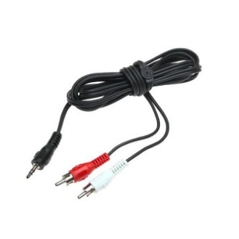
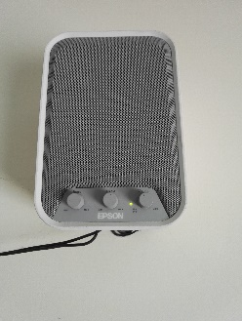

13

12

- Projection equipment on/off button
- Projection equipment VGA selection button
- Projection equipment HDMI selection button
- Control panel Power LED 9. HDMI socket
- Control panel sound button 10. RCA sound socket
- Control panel power button 11. VGA socket
- HDMI multiplier power adaptor 12. Loudspeaker
- Power cable of the control panels 13. Sound cable

Make sure that the power cables (8), the control panel of the projection are plugged in the IPS socket, the HDMI multiplier power adaptor cable (7) is plugged in the UPS plug, the power button (6) is switched on, and the power LED (4) is lit. The projection is set to on position by pressing the button (1). Open the laptop computer. In order to reflect the screen image of the laptop to the curtain, place the appropriate image cable into the VGA (11) or HDMI socket (9) located on the panel. The other end of the image cable is placed into the VGA or HDMI socket of the laptop. If VGA socket is used, then press button (2) and if HDMI socket is used press button (3). If the image is not automatically reflected on the curtain, press Windows+P keys () all together, and select the “Dublicate” option on the pop-up menu. If the sound system is to be used, it is required that the power LED of the loudspeaker (12) be lit, and the sound button be set to on position. Insert RCA end of the sound cable (13) into the RCA sound socket (10) and the other end into the computer sound socket.

