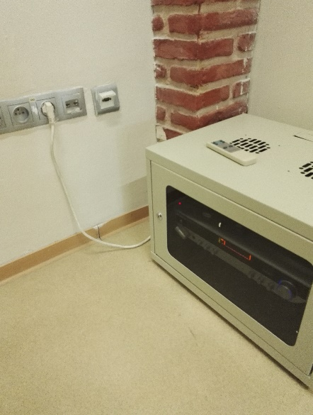
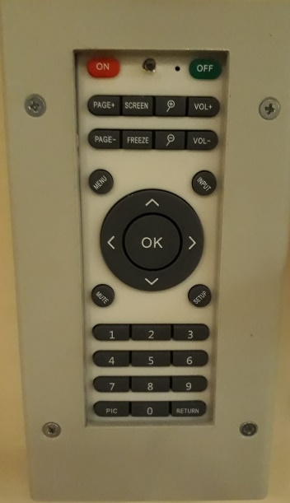
4

2
1
3
5

6

9

8

7

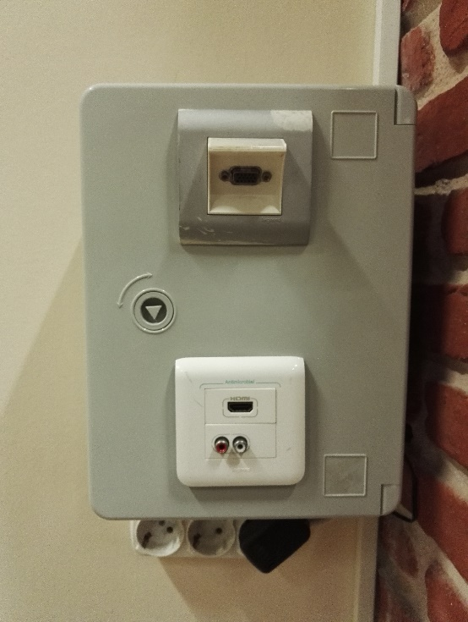
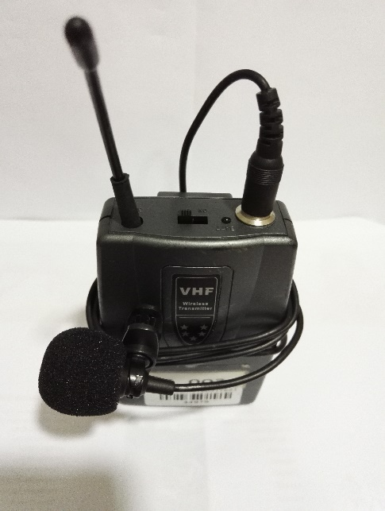

11

- Projection equipment on button
- Projection equipment off button
- Projection source selection button - “Screen”
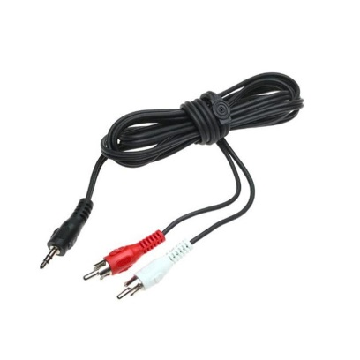
- Sound system power cable
- Sound system control
10

- Sound system amplifier
- VGA socket
- HDMI socket
- Sound input socket
- Sound cable
- Collar microphone on-off button

The projection devices are set to on position by pressing the button (1). Manually open up the projection curtains. Turn on the laptop. To reflect the display image of the laptop to the curtain, insert the VGA cable into the VGA socket (7) on the panel, or insert the HDMI cable into the HDMI socket (8) on the panel. Insert the other end of the cables into the VGA or HDMI socket of the laptop. Press “Screen” projection source selection button (3). If the image is not automatically reflected on the curtain, press Windows+P () keys all together, and select the “Dublicate” option on the pop-up menu. If the sound system is to be used, insert the sound system power cable (4) into the plug on the wall. Insert the RCA jack end of the sound cable (10) into the input (9) on the panel, and the other end into the sound socket of the laptop. If a collar microphone is to be used, the collar microphone for this class can be provided from metro security office. Insert the sound system power cable (4) into the plug on the wall. Slip “2” positions the microphone on-off button (11) to turn it on. Slip it “1” position (middle position) for setting the stand by” sleeping mode. The sound level can be set by the remote control(5).

