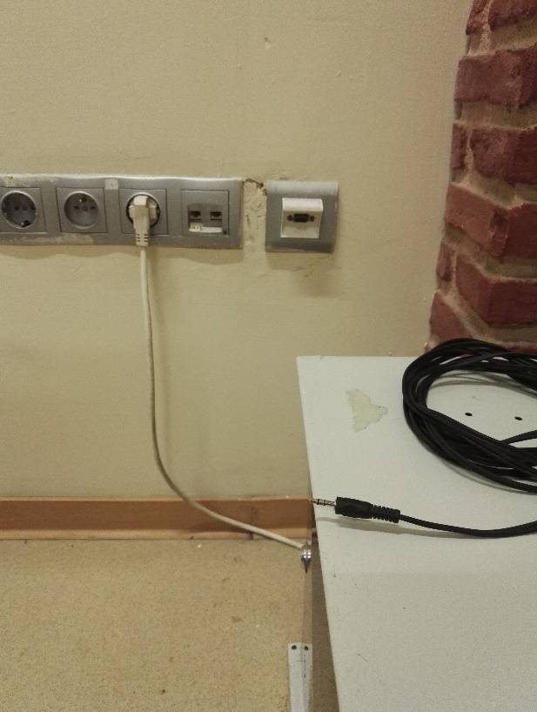
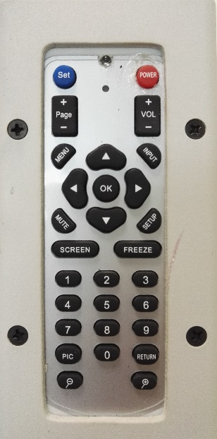
1

2

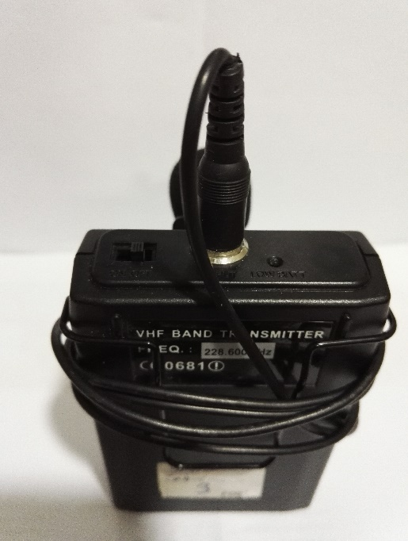
3
5

4

6

- Projection equipment on button
- Source Selection button “setup” for projection
- Sound System power cable
- VGA socket
- Sound cable
- Collar microphone on-off button

Projection equipment is set to on position by pressing the button (1). Manually open up the projection curtain. Turn on the laptop. To reflect the display image of the laptop to the curtain, insert the VGA cable into the VGA socket (4) on the wall. Insert the other end of the VGA cable into the VGA socket of the laptop. Press “Setup” projection source selection button (2). If the image is not automatically reflected on the curtain, press Windows+P () keys all together, and select the “Dublicate” option on the pop-up menu. If the sound system is to be used, insert the sound system power cable (3) into the sound socket (5) of the laptop. If a collar microphone is to be used, the collar microphone for this class can be provided from metro security office. Insert the sound system power cable (3) into the plug on the wall, slip “2” positions the microphone on-off button (6) to turn it on. Slip it “1” position (middle position) for setting the stand by” sleeping mode.

