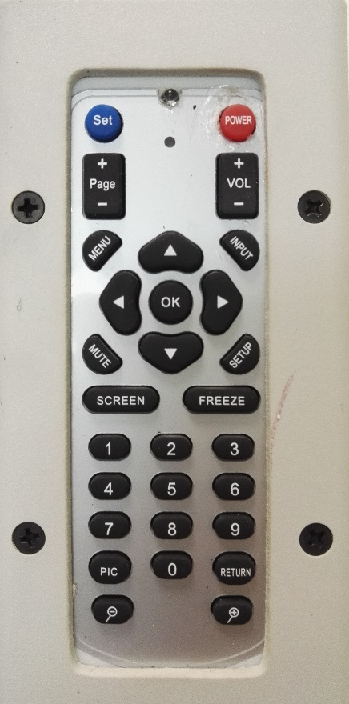

1

2

4

3

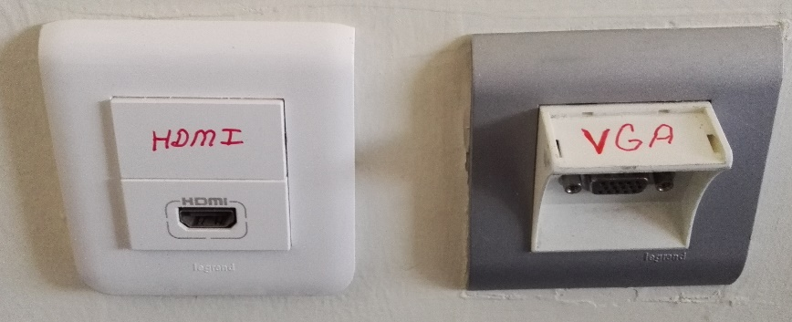

- Projection equipment on/off button
- Source selection button “Setup”
- VGA socket
- HDMI socket

Projection equipment is set to on position by pressing the button (1). Turn on the laptop. Manually open up the projection curtain. To reflect the display image of the laptop to the curtain, insert the image cable into the VGA or HDMI socket (3 or 4) on the wall. Insert the other end of the image cable into the VGA or HDMI socket of the laptop. Press “Setup” button (2). If the image is not automatically reflected on the curtain, press Windows+P () keys all together, and select the “Dublicate” option on the pop-up menu.

