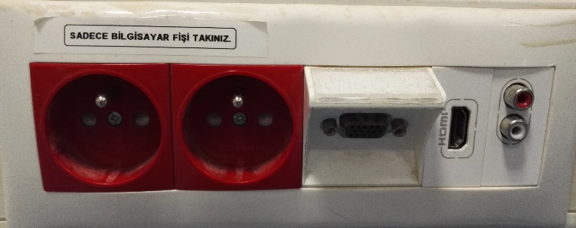
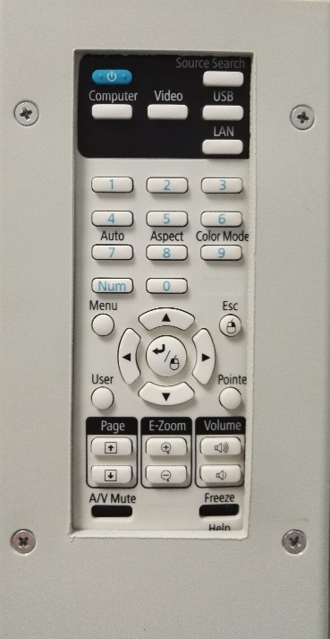
2
1

4

3

6

5

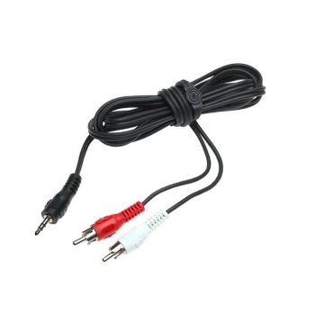
9

8

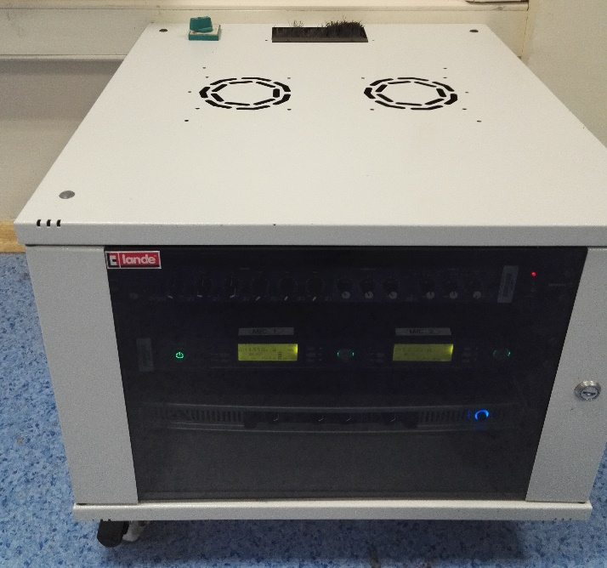
7

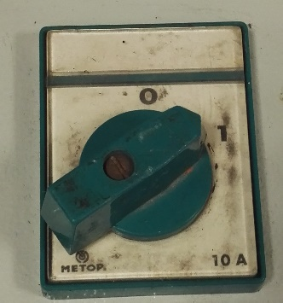

- Projection equipment on button
- Source Selection button - “Source search”
- Ups Electric Plugs
- VGA socket
- HDMI socket
- RCA Sound Input socket
- Sound system opening switch
- Sound system cabinet
- Mini Jack – RCA sound cable.

The projection devices are set to on position by pressing the button (1). Manually open up the projection curtain. Turn on the laptop. To reflect the display image of the laptop to the curtain, insert the image cable into the VGA or HDMI socket (4 or 5) on the cable channel. Insert the other end of the image cable into the VGA or HDMI socket of the laptop. Press “Source search” button (2). If the image is not automatically reflected on the curtain, press Windows+P () keys all together, and select the “Dublicate” option on the pop-up menu. If the sound system is to be used, set the sound system on-off switch (10) to “1” position. Insert the sound cable (7) into the smart desk’s or laptop’s sound socket. Place the RCA sockets of the sound cable (9) into the sound input socket (6) on the cable channel, and insert the mini jack side into the laptop’s sound socket. If a collar microphone is to be used, the collar microphones for this class can be provided from the department secretary’s office. If the sound system is on, it can be used by setting on the microphones via the on/off switch on the sound system.

